2017搖滾中樂節
Chinese Music Rocks!
Young Taiwanese Musicians Revolutionize Traditional Chinese Music
Lord Guan Yu’s Triumphant Return to the Stage

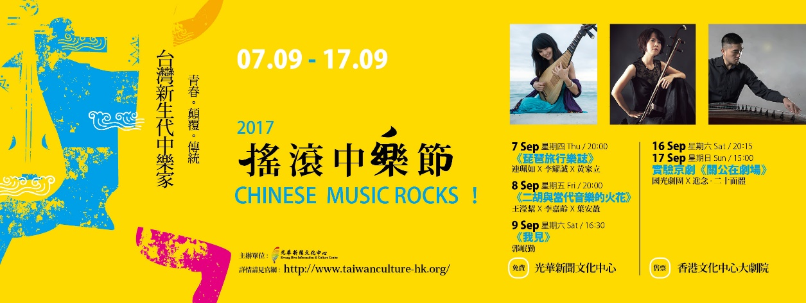

Starting from 7th Sep., Chinese Music Rocks! will lighten the stages of Kwang Hwa Information and Culture Centre and Hong Kong Cultural Centre, presenting 3 free concerts and one theatrical performance. Three upcoming Taiwanese musicians will be joining forces with local musicians, showing the true color and diversity of a new generation Chinese music. Moreover, Zuni Icosahedron and Guo Guang Opera Company will work together for the second time to bring a well-received play, Lord Guan Yu On Stage, back to Hong Kong Cultural Centre. Through these overseas experiences, Taiwanese Chinese music will pave its way to the world stage, presenting its unique tunes to global audiences. We can’t wait to feast on these renewing traditional concerts with you in cool autumn evenings.

Contemporary Horizon: Beyond Borders

On 7th Sep., Taiwanese pipa player, Pei Ju Lien will present Carnet de voyage, a series of new songs composed in Paris, featuring the two prominent Hong Kong musicians: frame drum player, John Lee, and celloist, Wong Ka Lap. Carnet de voyage will picture Lien’s metal landscapes for the audience, whispering her secrets as if it were a documentary, stirring imagination in the listeners.

On 8th Sep., the stage will belong to Ying-Chieh Wang, a Taiwanese erhu player, and two local musicians: Colleen Lee, star pianist, and, Adilia Yip, a percussionist who studied at Europe; the trio will present Erhu and Western Contemporary Music. In recent years, Wang has been working with many artists from different fields, and is often invited to play at concerts and music festivals, including the 5th Hong Kong Week in Taiwan as well as the 45th Hong Kong Arts Festival in which she premiered Ethereal Is the Moon, an erhu concerto, with Hong Kong Sinfonietta.

On 9th Sep., we present Kuo, Min-Chin, a Taiwanese zheng soloist and song writer, who reflects his life in musical notes, will perform What I See. Kuo takes inspiration in Diu Diu Dang, a folk song from his hometown, Ilan, and Kuyi's love, an ancient tune from the Paiwan Tribe; through such songs, Kuo paints a delicate picture of his homeland, Taiwan. New songs and sets from Kuo can be expected at Chinese Music Rocks!

Experimental Peking Opera: The Return of Lord Guan Yu On Stage

With overwhelmingly positive reviews from last year’s performance, Lord Guan Yu On Stage will return to Hong Kong Cultural Centre on 16th & 17th Sep.. The play begins with chivalric scenes which focus on Guan’s loyalty and valor. And through his five legendary triumphs, the stage is thus cleansed of the “Evils from Five (all) Directions”. Lord Guan Yu On Stage is the joint effort of Zuni Icosahedron and Guo Guang Opera Company and was flooded by compliments in last years performance. ' Lord Guan Yu On Stage defines the direction for the future of Peking Opera!’, exclaimed Hongzeng Rong, a retired professor of Music at the University of Pittsburgh.

Chinese Music Rocks! cordially invites you to explore the fascinating world of Chinese music and feel how these revolutionizing performances put a dash of innovation into traditional songs and plays.

For details and seats booking, please visit: www.taiwanculture-hk.org .
For tickets for Lord Guan Yu On Stage, please visit URBTIX.

…………………………………………………………………………………………
Media Contact： Kate Wen 6087-7119 Email: kate@taiwanculture-hk.org

