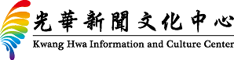
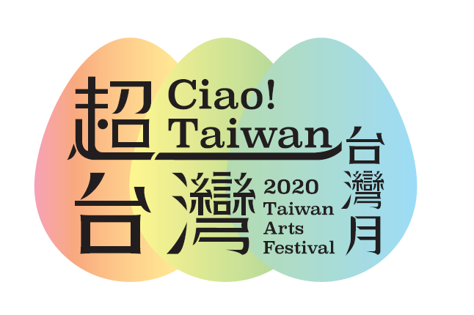
Press Release
2020.09.30
2020 Taiwan Arts Festival・Ciao! Taiwan
Taiwan-Hong Kong Cultural Exchanges
Transcending the Limits of Imagination

The Kwang Hwa Information and Culture Center proudly present the 15th Taiwan Arts Festival – “Ciao! Taiwan”. Scheduled to run from October 9 to November 22, this year’s Taiwan Arts Festival presents a rich programme of arts and cultural activities showcasing the transcendent creativity born out of Taiwan and Hong Kong’s cultural exchanges.

Linda Lu, the Acting Director of the Kwang Hwa Information and Culture Center, says: “This year is the 15th anniversary of Taiwan Arts Festival. It is a year for looking back at the past and towards the future. Facing the impact of the pandemic, we hope to use the power of the arts to cheer everybody up and overcome obstacles together. This year’s key visual design utilizes the Easter egg concept to represent blessings and hope; each event, like an Easter egg, opens up a different surprise. Their charm lies in precisely the infinite possibilities of Taiwan-Hong Kong cultural exchanges.”

The Taipei Economic and Cultural Office (TECO) also sends Taiwan Arts Festival its warm blessings to celebrate this 15th birthday, noting that the exciting cultural activities brought by the Taiwan Arts Festival every year are a testament to the cultural friendship between Taiwan and Hong Kong. TECO also welcomes everyone to bring their friends and family to experience Taiwanese culture that goes beyond the imagination.

Through diverse activities featuring film, theatre, new media, design, music, literature, and comics, this year’s Taiwan Arts Festival channels a spirit of transcendence that respects traditions as well as avant-garde innovation, utilizing creativity to transcend the boundaries of space and imagination.

Together with the Hong Kong Arts Centre, we present Hong Kong’s first ever film retrospective of Taiwanese filmmaker Wang Toon, featuring seven of his classic films depicting Taiwanese history and humanity. Having just been honored with the Golden Horse Lifetime Achievement Award, director Wang will also be conducting a masterclass to share the stories behind his films.

Taiwan’s first neoclassical dance troupe that combines both classical and modern dance will be bringing their signature performance, The Drifting Fate of Hakka, a story of ethnic migration and diaspora told through the theme of “co-existence” that will convey the infinite diversity of Hakka arts culture.

In a joint project with Hong Kong’s Zuni Icosahedron, we have invited Sylvia Chang, Yen Chun-chieh and Chiao Yuan-pu to co-create Piano Solo Storytelling Spirits, a moving performance fusing music, literature, poetry, light and shadow. This new Hong Kong version of the performance was crafted following the show’s highly acclaimed run in Taiwan last year.

In collaboration with the Microwave International New Media Arts Festival, we have developed a special Taiwan-themed storytelling project entitled “About Life & Death”. Co-produced by Joe Fang , Wu Chung-lun, Joel Kwong and Edward Chiu, the project utilizes interactive hypermedia and audiovisual multimedia to help audiences shuttle through the various stories as they ponder the value of life. International award winner and Taiwanese technology art pioneer Tao Ya-lun will also be bringing his latest philosophical virtual reality work. And Hong Kong artists Javin Mo and Keith Lam will head to openground design portal, where they will facilitate a deep exchange between cutting-edge designers from Taiwan and Hong Kong on the aesthetics styles of their respective art designs.

Meanwhile, the West Kowloon Cultural District will be inviting elite Taiwanese jazz artists Hsieh Min-yen and Lee Shih-yang and Hong Kong musicians Mike Yip and Daniel Chu for an impromptu online jam session that will challenge the audience’s perception of jazz music.

Additionally, Craftsmanship in Taiwan Way has invited Taiwan’s natural pigment artist Hung Hao-lun, Hands founder John Chiang, the Bank of Culture, and Mental Image to give Hongkongers a greater appreciation of Taiwan’s traditional crafts through exhibition, videos and DIY workshops.

Lastly, the Taiwan Creative Content Agency, Taiwan Comic Base, Creative Comic Collective (CCC), and Hong Kong Comics & Animation Federation Limited have joined forces to deliver a Taiwanese digital comic exhibition based on the “holy land pilgrimage” concept, inviting our Hong Kong friends to get to know Taiwan’s outstanding original comic artists and their works through a 2D cultural tour of Taiwan that can be embarked on anywhere, anytime.

2020 Taiwan Arts Festival’s online programme announcement will stream live on September 30. A prize giveaway competition will also kick off at the same time and run until October 8. Hong Kong residents are invited to participate for the chance to win a Taiwan Arts Festival/inBloom limited edition pandemic prevention gift pack.

Please visit the Kwang Hwa Information and Culture Centre website for the latest event information.
(http://hk.taiwan.culture.tw) or Facebook page
Media Kit QR Code：
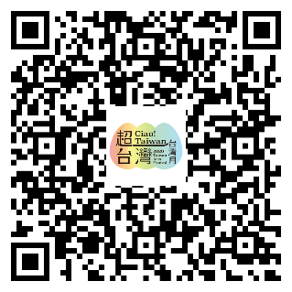
…………………………………………………………………………………………
Media contact： Hsu Chen Yu 2588-7997 Email: megarmoc@gmail.com

