揭幕：尋探立陶宛攝影中的認同
Uncoverings: the Search for Identity in Lithuanian Photography
作品圖說Plates and Work Information
編號No. | 作品圖片  Image | 作品圖說  Work Information
1 |  | 羅穆豪達斯．波澤斯基斯 〈朝聖，第155號〉  1989 明膠銀鹽相紙 22.7 x 32.7公分（影像）立陶宛國家美術館藏
Romualdas Požerskis Pilgrimages, No.155 1989 Gelatin silver print
22.7 x 32.7 (image) Collection of the Lithuanian National Museum of Art
2 | 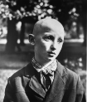 | 安塔納斯．蘇庫斯〈盲眼的小紅軍〉1962  明膠銀鹽相紙56 x 46.3公分 立陶宛國家美術館藏
Antanas Sutkus Blind Pioneer 1962
Gelatin silver print 57.4 x 46.3 cm
Collection of the Lithuanian National Museum of Art

3 | 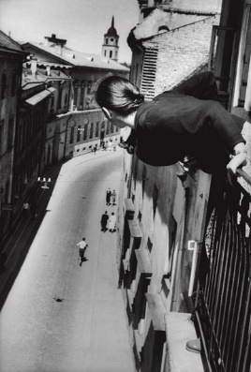 | 安塔納斯．蘇庫斯 〈大學路上的馬拉松跑者〉1959  明膠銀鹽相紙 57.4 x 38公分 立陶宛國家美術館藏
Antanas Sutkus Marathon at University Street 1959
Gelatin silver print 57.4 x 38 cm
Collection of the Lithuanian National Museum of Art
4 | 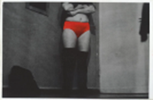 | 亞爾吉達斯．赦斯庫斯 〈無題〉1975-1983  手工上色於明膠銀鹽相紙 12 x 18公分 立陶宛國家美術館藏
Algirdas Šeškus Untitled 1975–1983
Hand-coloured on gelatin silver print 12 x 18 cm
Collection of the Lithuanian National Museum of Art
5 | 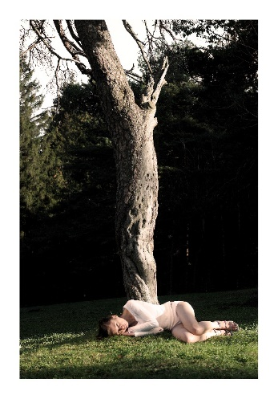 | 勞拉．加布施蒂恩〈我該怎麼做才能讓獨角獸把頭靠在我的腿上？〉  2006 數位輸出80 x 54 公分 藝術家提供
Laura Garbštienė What Should I Do so That the Unicorn Would Come and Lay Its Head on My Lap?
2006 Digital Print 80 x 54 cm Courtesy of the artist

覆寫真實：臺灣當代攝影中的檔案與認同
Covered Reality: Archival Orientation and Identity in Taiwanese Contemporary Photography
作品圖說Plates and Work Information

編號No. | 作品圖片  Image | 作品圖說  Work Information
6 | 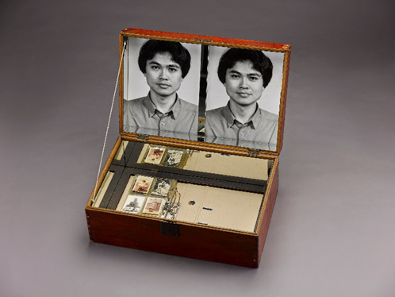 | 陳順築 〈家族黑盒子—自傳〉1992  照片、相框、壓克力板、油漆、棉線、木料、檔案夾、相簿活頁、鏡子、老木箱、蠟、中藥、壓克力色料、報紙  64 × 39 × 23 公分 國立臺灣美術館典藏
CHEN Shun-Chu Family Black Box—Autobiography 1992
Photo, photo frame, acrylic sheet, paint, cotton thread, wood, file folder, album leaflet, mirror, old wooden box, wax, Chinese medicine, acrylic paint, newspaper64 × 39 × 23 cm
Collection of the National Taiwan Museum of Fine Arts
7 | 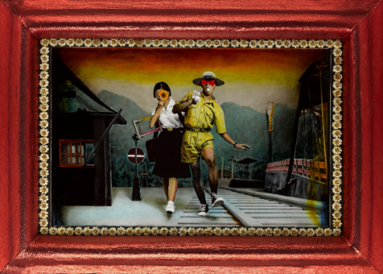 | 吳天章 〈戀戀紅塵〉 1997  油彩、相紙、亮片、人造花、金蔥布160 × 220 × 13 公分 （含框）國立臺灣美術館典藏
WU Tien-Chang Attachment to the Mundane World 1997
Oil painting on digital print, sequins, artificial flowers, metallic woven fabric 160 × 220 × 13 (framed)
Collection of the National Taiwan Museum of Fine Arts
8 | 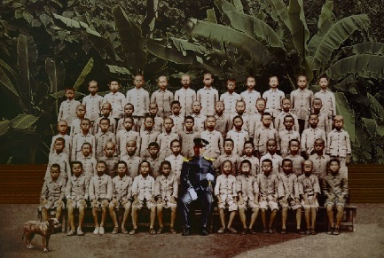 | 梅丁衍 〈尋找黃土水〉2008數位影像輸出  119.5 × 179 公分 國立臺灣美術館典藏
MEI Dean-E Looking for Huang Tu-Shui 2008
Digital print on laser printing paper 119.5 × 179 cm
Collection of the National Taiwan Museum of Fine Arts
9 | 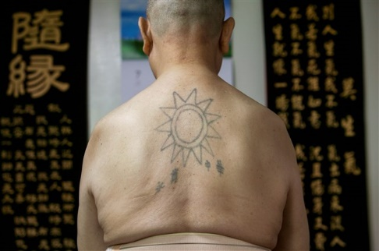 | 黃子明 〈韓戰反共戰俘的政治紋身：廖禮華〉2013  數位輸出 47.6 × 68 公分 國家攝影文化中心典藏
HUANG Tz-Ming
Anti-communist Tattoo on Prisoners-of-war from the Korean War: LIAO Li-Hua
2013 Digital print47.6 × 68 cm
Collection of the National Center of Photography and Images

10 | 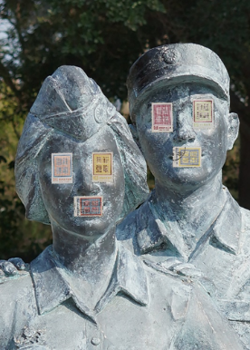 | 藍仲軒〈莊敬自強〉2022無酸噴墨相紙、郵票  42 x 30 公分  藝術家提供
Lan Chung-Hsuan Be Careful and be Strong 2022
Archival inkjet print, stamps 42 x 30 cm Courtesy of the artist

