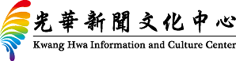

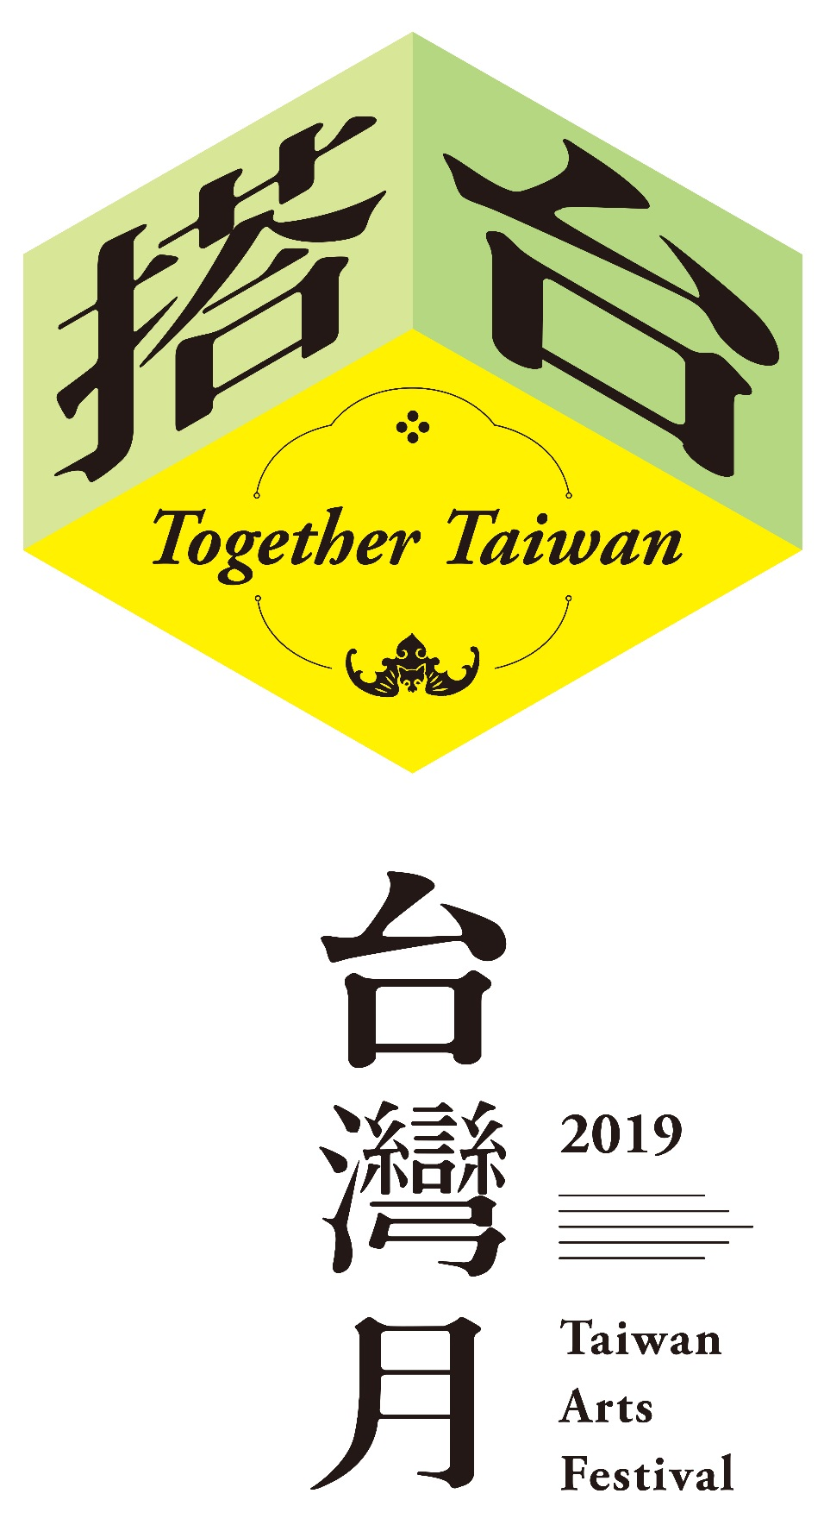

**Press Release**

2019.09.18

**2019 Taiwan Arts Festival – Together Taiwan**

**Taiwan & Hong Kong join hands to build exciting cultural exchange platform**

The Kwang Hwa Information and Culture Center has announced that the theme of the 14th Taiwan Arts Festival will be “Together Taiwan”, a reflection of the unlimited potential of connecting Taiwan and Hong Kong culture and creativity. This year’s festival, to be held from Oct. 4 to Nov. 19, is highlighted by fusions of the traditional and the contemporary, innovative cross-disciplinary art forms, and a spirit of social concern and humanistic care.

Kao Ming-tsun, acting head of the Taipei Economic and Cultural Office in Hong Kong, said Taiwan Arts Festival has brought countless surprises and moving moments over the years by delivering performances, exhibitions and special events that resonate with people’s lives and touch their hearts, making it an arts and culture celebration that Hongkongers eagerly look forward to every year.

Linda Lu, acting director of the Kwang Hwa Information and Culture Center, said Taiwan Arts Festival is actively fulfilling its role as a facilitator of diverse exchanges by working hand-in-hand with its partners to build a platform and stage that can showcase the rich fruits of Taiwan-Hong Kong collaboration. It is also hoped that these deep exchanges can create new opportunities for both cultures, she added.

The 2019 Taiwan Arts Festival has three main sections — *The Masters: Refined by Time*, *The Platform: Interactions of Collaborations*, and *The New: Voices of Diversity*. From inheriting the artistic essence and wisdom of great masters, to explosive Taiwan and Hong Kong cultural collaborations, to the innovative and diverse voices of the new generation, this year’s festival will present Taiwan’s flourishing culture and arts as well as the outstanding results of Taiwan-Hong Kong cultural exchanges.

***The Masters: Refined by Time***

Through an intimate conversation, the film screening of *The Walkers*, and the Poetry in Motion Performance and Workshop, dance choreographer Lin Lee-chen personally presents the uniquely slow and meticulous aesthetics of The Legend Lin Dance Theatre, guiding audiences to participate in a profound and magnificent festival of life. International auteur Tsai Ming-liang brings his latest visual work, a short film inspired by Taiwan and Hong Kong culture, combined with an improvised musical performance that will conjure Taiwan and Hong Kong’s shared memories of cinema. In a collaboration with M+, at the West Kowloon Cultural District, we present a special selection of restored Taiwanese films, including classic works by renowned directors such as King Hu and Richard Chen Yao-Chi. Li Cheuk-to, Curator, Hong Kong Film and Media, M+, and electronic musician Huang Kai-Yu discuss how to breathe new life into old movies. Meanwhile, the Hong Kong Arts Centre has organised a special Audience’s Choice screening of Ko I-cheng’s Taiwanese experimental film classic *Blue Moon*, giving audiences the opportunity to vote on their preferred sequential order of the film’s five parts.

***The Platform: Interactions of Collaborations***

Acting Executive Director, Performing Arts and Artistic Director, Performing Arts of West Kowloon Cultural District Authority, Alison Friedman presents three collaborations between Kwang Hwa Information and Culture Center and Freespace: “Edward Lam Dance Theatre – Art School Musical”, an intimate interaction between Taiwan and Hong Kong theatre; “Taiwan Arts Festival X Freespace Jazz Fest”, a full weekend of indoor and outdoor performances from a line-up that includes the indigenous Taiwanese experiment rock band Outlet Drift and a group of Taiwanese and Japanese musicians of the album “Cloud Wandering” led by sanshin master Takashi Hirayasu; and “Contemporary Classical Music Exchange Programme”, an exploration of new possibilities in contemporary music composition featuring Studio Acht and the Hong Kong New Music Ensemble.

In the other parts of this section, artist Chiao Yuan-pu once again teams up with the University of Hong Kong to present a musical appreciation of Alexander Pushkin’s amazing literary works. Event curator Liu Sau Ming and former “object a” director Fong Tai Chor share how they assembled four groups of Hong Kong and Taiwan poets and musicians for “Noise/Voice”, a crossover concert that transcends the boundaries of poetry and music. And in “Voice in Hong Kong”, five new media Taiwanese sound artists come together for a rare and diverse collaborative demonstration performance.

***The New: Voices of Diversity***

In collaboration with Hong Kong International Photo Festival, Lightbox Photo Library founder Tsao Liang-pin embarks on an exploration of Taiwanese photobooks over time and their connection to contemporary society. Musician Wang Yu-jun is invited to an in-depth exchange with Hong Kong artists and will guide us on a journey of “A Beautiful Time” through music. Together with the Microwave International New Media Arts Festival, we present the works of Taiwanese artist Ku Kuang-yi, Chiu Hsiao-wei (Ipa) and Huang Pang-chuan, blending food, memories and home to reconstruct the past and open up the future. Fiber artist Kang Ya-chu, as artist-in-residence at the Centre for Heritage, Arts and Textile (CHAT), will weave her performance based on real-life stories of Hong Kong’s female textile workers. “One Map”, inspired by Taiwan’s mountains and oceans, is an exhibition of Taiwan’s charming design arts and lifestyle aesthetics. And finally, Taiwan Bar, which uses cute animations and humorous dialogue to reflect on Taiwanese history and contemporary society, has produced its first exclusive animation for Taiwan Arts Festival, comparing Taiwan and Hong Kong’s pop culture differences and similarities.

For the latest information on the 2019 Taiwan Arts Festival, please visit the Kwang Hwa Information and Culture Center website (<http://hk.taiwan.culture.tw)> or official Facebook page (@khicc).

Information pack QR code:



…………………………………………………………………………………………

新聞聯絡人： 徐承郁 2588-7997 Email: [megarmoc@gmail.com](mailto:megarmoc@gmail.com)  
盧筱萱 6023-2358 Email: lindalu@moc.gov.tw

Media contacts: Hsu Chen Yu 2588-7997 Email: [megarmoc@gmail.com](mailto:megarmoc@gmail.com)

Linda Lu 6023-2358 Email: lindalu@moc.gov.tw